- All patients prescribed an oral anticoagulant require a patient safety card (also known as an alert card) which provides appropriate details of their treatment. Currently there are multiple versions in use:
DRAFTddhjehfeh

Use of a single anticoagulant patient safety card across Surrey
  - A National Patient Safety Agency (NPSA) Anticoagulant Alert Card is given to all patients prescribed Vitamin K Antagonists (VKAs), while

  - Patients on Direct Oral Anticoagulants (DOACs- Direct-acting oral anticoagulants) receive an alert card produced by individual manufacturers. The variability and change of their design can pose a risk to patients and healthcare professionals may not always recognise a patient is on an oral anticoagulant.
- To ensure all healthcare professionals (HCP) across primary and secondary care can identify patients taking an oral anticoagulant, a standardised approach across Surrey has been taken by implementing the use of a single patient safety card for all oral anticoagulants (VKA or DOAC).
- The alert card should be filled in and given to the patient as part of the written information provided at the start of their treatment and informed to carry it with them at all times. HCPs should take every opportunity to check and ensure a patient is carrying an anticoagulant alert card throughout the course of their treatment. This may include: at hospital discharge, clinic follow up, General Practitioner appointment, medicine reviews and/ or getting their anticoagulant dispensed from the community pharmacy.
Information for healthcare professionals on standardising the use of a single oral anticoagulant safety card across Surrey
- The existing NPSA Anticoagulant Alert Card is a recognised tool and should be used for all patients prescribed an oral anticoagulant (VKA or DOAC) in Surrey.
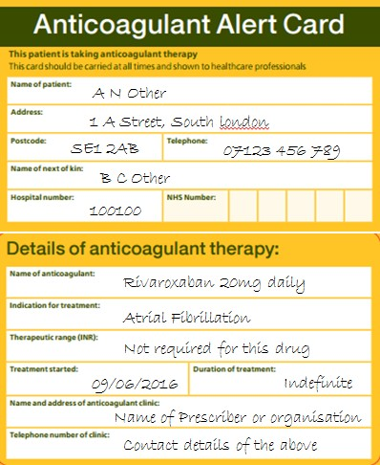
- It is the size of a credit card and can easily be carried by the patient. It provides patient details and information of their anticoagulant treatment (including: the anticoagulant prescribed, its indication, duration and contact details of their anticoagulant service or prescriber).
- If a patient is prescribed a VKA, then the therapeutic range for International Normalised Ratio (INR)
details must be completed accordingly. If a patient is prescribed a DOAC, this section should state “Not required for this drug”, as an INR is not needed for DOACs.
- A single pack containing 50 anticoagulant alert cards can be ordered using the NHS Order Portal from Xerox (UK) Ltd with the order code ‘OATALERTCARD’. For organisations not registered with Xerox (UK) Ltd, visit www.nhsforms.co.uk website where the appropriate registration form is available for completion. Alternatively contact their help desk number on 0300 123 0849 for further information. The cost of a single pack containing 50 anticoagulant alert cards is £3.35 (excluding VAT, August 2022).
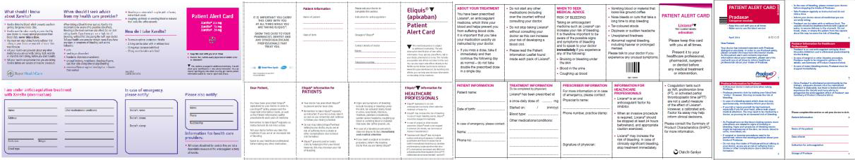
USEXNPSA ANTICOAGULANTXALERT CARD FORXALL ORAL ANTICXOAGULANTS

(VKA or DOAC)
Developed by South London Cardiovascular Medicines Working Group: 29.06.2016, Updated by Surrey Heartlands ICB August 2022 Review date: September 2023 (or earlier if indicated) Approved by Surrey MCG: November 2016

